Roni Kaakaty

Week 3.2 Exercises

Area Plot in Python

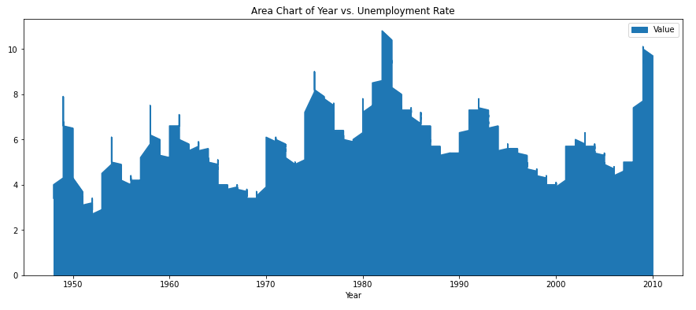

Stacked Area Chart in Python

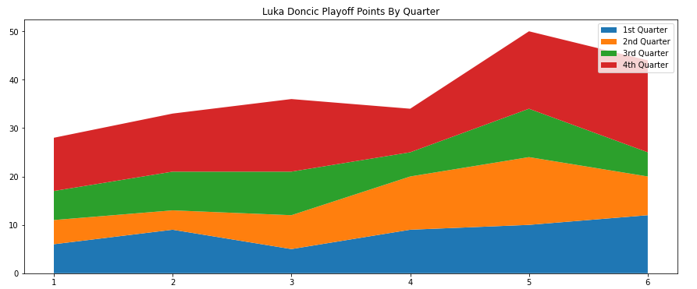

Treemap in Python

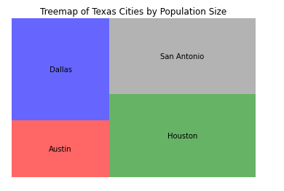

Area Plot in R

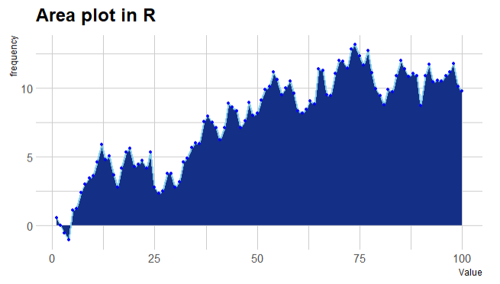

Stacked Area Chart in R

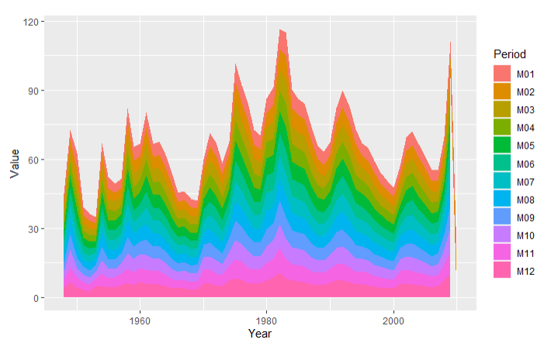

Treemap in R

Population Size of Cities in Texas

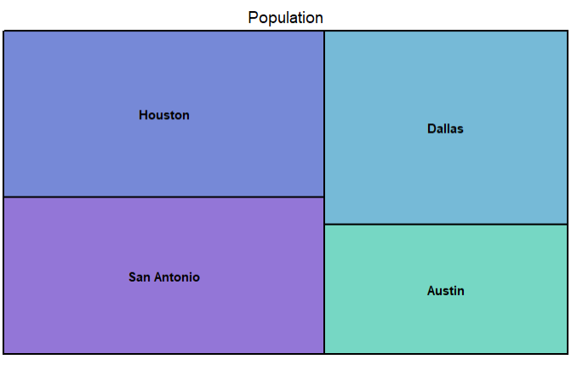

Area Chart in PowerBi

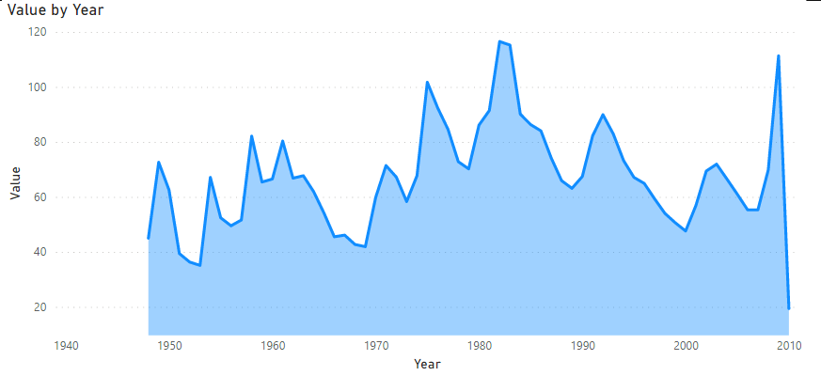

Stacked Chart in PowerBi

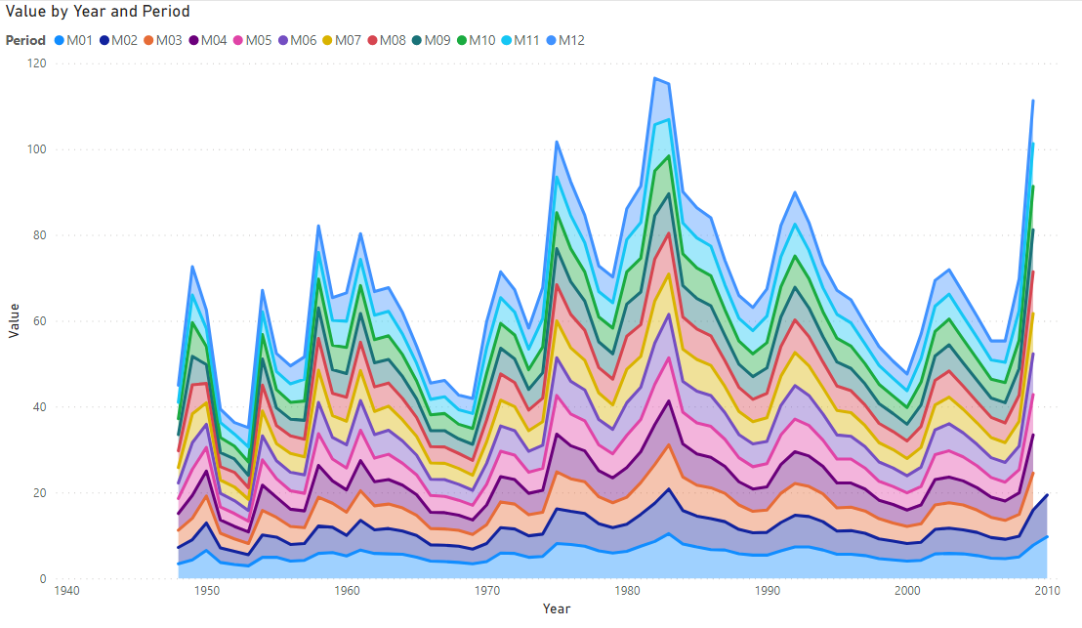

Treemap in PowerBi

Treemap of Unemployment Rate by Month

